Problem Set #1

Due Monday, September 18 by 3:00 PM

**Note: 1KB = 1024 bytes, 1MB = 1024 KB, 1GB = 1024 MB**

Problem 1 – (10 pts)

Suppose a 2-Gbps point-to-point link is being set up between the Earth and a new lunar colony. The distance from the moon to the Earth is approximately 385,000 km, and data travels over the link at the speed of light—3×108 m/s.

(a) Calculate the minimum RTT for the link. (2 pts)

(b) Using the RTT as the delay, calculate the delay × bandwidth product for the link. (2 pts)

(c) What is the significance of the delay × bandwidth product computed in (b)?

(3 pts)

(d) A camera on the lunar base takes pictures of the Earth and saves them in digital format to disk. Suppose Mission Control on Earth wishes to download the most current image, which is 30 MB. What is the minimum amount of time that will lapse between when the request for the data goes out and the transfer is finished? (3 pts)

Problem 2 – (4 pts)

What is the throughput when retrieving a 4MB file across a 1Gbps network with a round trip time of 150msec, again ignoring ACKs?

1. Assuming that the file transfer has to be initiated by a request.
2. Otherwise.

Problem 3 – (10 pts)

Calculate the total time required to transfer a 2000-KB file in the following cases, assuming an RTT of 100 ms, a packet size of 1 KB data, and an initial 2×RTT of “handshaking” before data is sent:

(a) The bandwidth is 1 Mbps, and data packets can be sent continuously. (2 pts)

(b) The bandwidth is 1.5 Mbps, but after we finish sending each data packet we must wait one RTT before sending the next. (2 pts)

(c) The bandwidth is “infinite,” meaning that we take transmit time to be zero, and up to 40 packets can be sent per RTT. (2 pts)

(d) The bandwidth is infinite, and during the first RTT we can send one packet (21−1), during the second RTT we can send two packets (22−1), during the third we can send four (23−1), and so on. (4 pts)

Problem 4 – 2 pts

Determine the width of a bit on a 20 Gbps link. Assume a copper wire, where the speed of propagation is 2.3 ∗ 108 m/s.

Problem 5 – 4 pts

Consider four stations that are all attached to two different bus cables. The stations exchange fixed-size frames of length 1 second. Time is divided into slots of 1 second. When a station has a frame to transmit, the station chooses either bus with equal probability and transmits at the beginning of the next slot with probability p. Find the value of p that maximizes the rate at which frames are successfully transmitted.

Problem 6 – 6 pts

Suppose there is a 10 Mbps microwave link between a geostationary satellite

and its base station on Earth. Every minute the satellite takes a digital photo and

sends it to the base station. Assume a propagation speed of 2.4 x 108 meters/sec.

(a) What is the propagation delay of the link? (2 pts)

(b) What is the bandwidth-delay product, R x (propagation delay)? (2 pts)

(c) Let *x* denote the size of the photo. What is the minimum value of *x* for the

microwave link to be continuously transmitting? (2 pts)

Problem 7 – 9 pts

Consider the Go Back N algorithm with a sender window size of 4 and a sequence number range of 1,024. Suppose that at time t, the next in-order packet that the receiver is expecting has a sequence number of k. Assume that the medium does not reorder messages. Answer the following questions:

(a) What are the possible sets of sequence numbers inside the sender’s window

at time t? Justify your answer. (3 pts)

(b) What are all possible values of the ACK field in all possible messages currently

propagating back to the sender at time t? Justify your answer. (3 pts)

(c) With the Go-Back-N protocol, is it possible for the sender to receive an ACK for a packet that falls outside of its current window? Justify your answer with an example. (3 pts)

Problem 8 – 8 pts

Draw a time line diagram for the sliding window algorithm with SWS = RWS = 3 frames, for the following two situations. Use a timeout interval of about 2 × RTT. And assume 2 frames must be send ½ RTT apart which means if everything is normal Sender will receive ACK and then immediately send the next frame.

1. Frames 3 and 6 are lost on their first transmissions. Draw the algorithm with time line diagram till Frame 6 is sent. (8pt)

**Sample time diagram –**

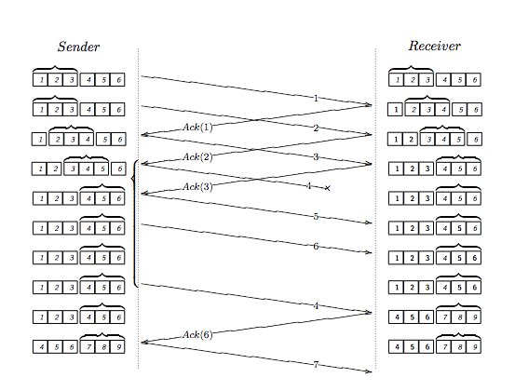

Problem 9 – 8 pts

Draw a timeline diagram (up to frame 7) that for the sliding window algorithm with SWS=4 frames and RWS=3 frames, when the third frame (frame 2) is lost. The receiver uses cumulative ACKs. Use a timeout interval of about 2 x RTT. Assuming that the transmit time (insertion delay) of a frame is equal to 0.25 RTT and the frames can be processed instantaneously if they arrive in order.

On each data frame and ACK frame, you need to indicate the sequence number (start from 0). In addition, you need to indicate what action is taken by the receiver of when it is received, when ack is sent for a frame, if a frame is discarded or if it is buffered till waiting for cumulative ACK.

Problem 10 – 8 pts

Consider the sliding window algorithm with SWS = RWS = 5 and MaxSeqNum = 9. The Nth packet DATA [N] contains N mod 9 in its sequence number field.

Show an example in which the algorithm becomes confused, no packets may arrive out of order. **DRAW IT OUT use the same suggested format in Problem 8 -** that is, a scenario for example which the receiver expects DATA[9] and accepts DATA[0]—which has the same transmitted sequence number. Notice that this implies that MaxSeqNum > 9 is necessary and sufficient.

Problem 11 – 4 pts

Suppose you are designing a sliding window protocol for a 1-Mbps point-to-point link to a stationary satellite revolving around earth at an altitude of 3 x 104 km. Assuming each frame carries 1KB of data.

a) What is the optimal window size and why? (2 pts)

c) What will the window size be if the data rate is tripled? (2 pts)

Problem 12 – 5 pts

Sketch the NRZ, Manchester, and NRZI encoding for the bit stream 0001110101. Assume that the NRZI signal starts out low.

Problem 13 – 6 pts

Suppose you are designing a sliding window protocol for a 4­Mbps point­to­point link that is 9 x 104 km long. Assuming each frame carries 4 KB of data, what is the minimum number of bits you need for the frame sequence numbers if –

a) RWS=1 (2 pts)

b) SWS = RWS (2 pts)

c) If we use the Stop­and­Wait ARQ protocol, what would be the maximum

efficiency (defined as frames in transit/maximum possible frames in transit) that

we can achieve? (2 pts)

**Trace Route and Ping Assignment (16 pts)**

Please remember to turn in traces (copies) of the output of your ping and traceroute commands (in addition to answering the required questions)!

The primary aim of this component of the problem set is to collect and analyze ping traces from a set of wide-ranging locations. Ping is a program that allows a user to collect roundtrip time (RTT) samples from remote hosts. Ping can also be used to see if a remote host is up and running (i.e. if it responds to the ping, then it's alive).

On CS UNIX/Linux accounts, ping can be found in /bin/ping or /usr/sbin/ping. For more help, type "man ping" to your UNIX prompt to get the man page (also included below). On other UNIX platforms, it is also found in /usr/etc. Ping is also found on Windows machines within the Windows Command Prompt, by just typing 'ping'. The specifics of the 'ping' command line parameters varies according to the platform you use, so consult your local platform's man pages.

Here is a sample command that shows how to use ping

ping -c 10 -s 200 [www.colorado.edu](http://www.colorado.edu/)

This command will tell ping to send a ping packet of size 200 bytes once per second to remote host [www.colorado.edu](http://www.colorado.edu/) , and will stop after 10 pings. On some systems, the minimum data packet size may be 128 bytes. It will generate the following output:

PING www.colorado.edu (128.138.129.98): 200 data bytes

208 bytes from 128.138.129.98: icmp_seq=0 ttl=251 time=2.633 ms

208 bytes from 128.138.129.98: icmp_seq=1 ttl=251 time=3.748 ms

208 bytes from 128.138.129.98: icmp_seq=2 ttl=251 time=2.747 ms

208 bytes from 128.138.129.98: icmp_seq=3 ttl=251 time=3.172 ms

--- www.colorado.edu ping statistics ---

4 packets transmitted, 4 packets received, 0.0% packet loss

round-trip min/avg/max/stddev = 2.633/3.624/7.478/1.499 ms

The time quoted above is the roundtrip time, and is measured from the time the ping packet is sent to the time the ping echo reply arrives back at the sender.

Here is a sample command that shows how to use traceroute.

traceroute google.com

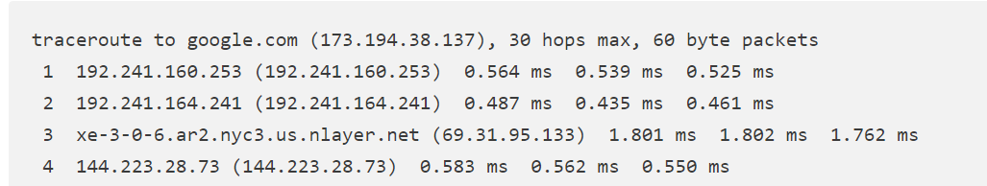

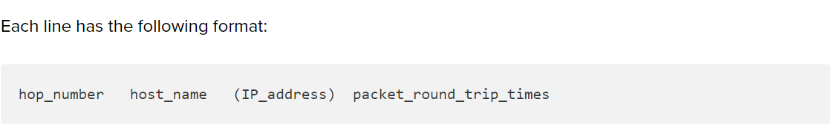

Alternatively, for Windows -

In the following example of the tracert command and its output, the packet travels through two routers (157.54.48.1 and 11.1.0.67) to get to host 11.1.0.1. In this example, the default gateway is 157.54.48.1 and the IP address of the router on the 11.1.0.0 network is at 11.1.0.67.

The command:

C:\>tracert 11.1.0.1

The output from the command:

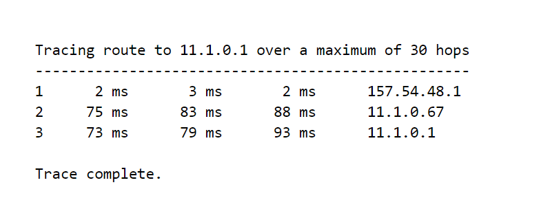

1. Perform a Traceroute between source and destination on the same continent

at three different hours of the day.

1. Find the average and standard deviation of the round-trip delays at each of the three different hours. (2pts)
2. Find the number of routers in the path at each of the three hours. Did the paths change during any of the hours? (2pts)
3. Try to identify the number of ISP networks that the Traceroute packets pass through from source to destination. Routers with similar names and/or similar IP addresses should be considered as part of the same ISP. In your experiments, do the largest delays occur at the peering interfaces between adjacent ISPs? (2pts)
4. In this section, you should generate the following table of averaged RTT's for

three different destination servers at three different times of the day.

For each combination of destination server and time of day in the table, you should collect four ping traces and then compute an averaged RTT over the four ping traces. Each ping trace should consist of 20 samples. Choose a packet size anywhere from 200 bytes to 500 bytes. For your source, use any local host at CU. For your destinations, select one destination server from each of the three categories (Local, National, and International) listed at the end of this assignment.

For example, if you chose the server berkeley.edu as your national destination server and csel.cs.colorado.edu as your local source, then run ping four times in the morning from csel to berkeley, four times in the afternoon, and four times late at night from csel to berkeley.

What was the averaged roundtrip time to each server at each of the three different times of day? To answer, please fill in the below table for averaged RTT. (2pts)

|  |  |  |  |
| --- | --- | --- | --- |
| Average RTT | Local | National | International |
| Morning |  |  |  |
| Afternoon |  |  |  |
| Late Night |  |  |  |

Server of choice:

Local:

National:

International:

1. Was there significant variation of the average RTT over the course of the day? How would you explain the variation, if any? (2pts)
2. What was the average packet loss to each server at each of the three different times of day? Please hand in your averaged values in a table form for packet loss. Was there significant variation of packet loss over the course of the day? Please explain. (2pts)

|  |  |  |  |
| --- | --- | --- | --- |
| Average Packet Loss | Local | National | International |
| Morning |  |  |  |
| Afternoon |  |  |  |
| Late Night |  |  |  |

1. Was there significant variation of average RTT with respect to geographic location, and how would you explain the variation, if any? (2 pts)
2. What is your estimate of the propagation delay to each server? Explain your methodology for inferring the propagation delay from the RTT estimates. What are the predicted propagation delays if you were to draw a shortest-distance line between Boulder and the location of each server? Explain the difference between your predicted propagation delays and the propagation delays inferred from your RTT's, if any. (2pts)